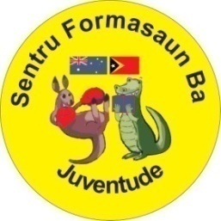

Sentru Formasaun Ba Juventude
Aldeia Moris Foun, Suco Comoro, Sub-Distritu Dom Aleixo, Dili, Timor-Leste
Contact Number: +670 73647796; E-mail: ebleakley@live.com

“SENTRU FORMASAUN BA JUVENTUDE NO COMUNIDADE”
PROJECT NO 33/2014-15

Floods and Covid Update Timor-Leste – 10 May 2021
There are now over 3,000 COVID cases in Timor-Leste, which is expected to rise due to the Easter weekend floods and the displacement of families. inal emergency relief following the Easter
We know through the Australian Embassy that Australia’s latest support includes –
- AUD 7 Million in additional emergency relief following the floods over the Easter weekend.
- Installation of 33 water tanks across 25 sites including evacuation centres and affected communities to provide emergency water supplies and reduce the risk of water-borne diseases.
- Immediate provision of food, water, hygiene kits and bedding to the most vulnerable people in evacuation centres through NGOs.
- Psychological support to those in evacuation centres (including children).
- Immediate support in the aftermath of the flooding to restore essential services such a power and water at critical sites, including the Integrated Crisis Management Centre, the National Laboratory and COVID-19 isolation centres.
- Delivery by the Royal Australian Air Force of more than 27 tonnes of emergency relief materials, including PPE, hygiene, kitchen and shelter kits.
- Initial deployment of the first two members of an Australian Medical Assistance Team (AUSMAT)- health specialists to work with the Ministry of Health’s surveillance team to manage public health needs from COVID-19 and the flooding.
- Defence Cooperation Program funding and personnel to support the FFDTL’s (Military) provision of emergency power, planning, food, water and clean-up activities.
- Connectivity support through the Pacific Flights Program to ensure essential humanitarian supplies, medical stores and personnel can travel to assist the response effort.
- Australian Federal Police support to the PNTL (Police) to maintain operations after the floods and continue its focus on border posts and the delivery of enhanced training to combat gender-based violence.
- AUD 24.3 million to support Timor-Leste’s vaccine access, including practical and technical support for the COVAX rollout (including cold chain and supply management, logistics and public health education), and an offer to supply Australian-manufactured AstraZeneca vaccines to enable timely rollout at a time when the international supply of vaccines is constrained.
(source-17 April Aust Embassy newsletter)
Timor Learning Centre
Timor has been in lockdown since the beginning of March and thus our Centre Gym and English school have been closed. I continually liaise daily with our Manager and Assistant Manager Dede and Atisi, in relation to our outreach programs.
Some of our women have been able to attend the sewing Centre to continue sewing face masks, as they are considered essential workers.
Dede and Atisi have been organising outreach to the local Don Bosco School and convent where there were over 800 displaced families.
To date we have raised over $10,000 AUD (since 12 April 2021), for the floods and covid relief.
We have donated to the Don Bosco Emergency Centre –
- 100 Face masks sewn at our centre ($200 USD)
- 188 Tote bags sewn at our Centre ($940 USD)
- 40 Small toiletry bags sewn at our Centre ($120 USD)
- 65 Plus Fitness water bottles (donated)
- 35 Plus Fitness T-Shirts (donated)
- Boxes of new children’s/baby clothes/wraps and woollen blankets (donated)
- 300 Days for Girls Feminine Hygiene Kits (donated)
- Boxes of knitted beanies (donated)
We have also donated face masks to the Australian Doctors at Maluk Timor Medical Centre to disperse-
- 300 face masks sewn at our Sewing Centre- ($600 USD)

- TOTAL COST TO CENTRE - $1,860 USD
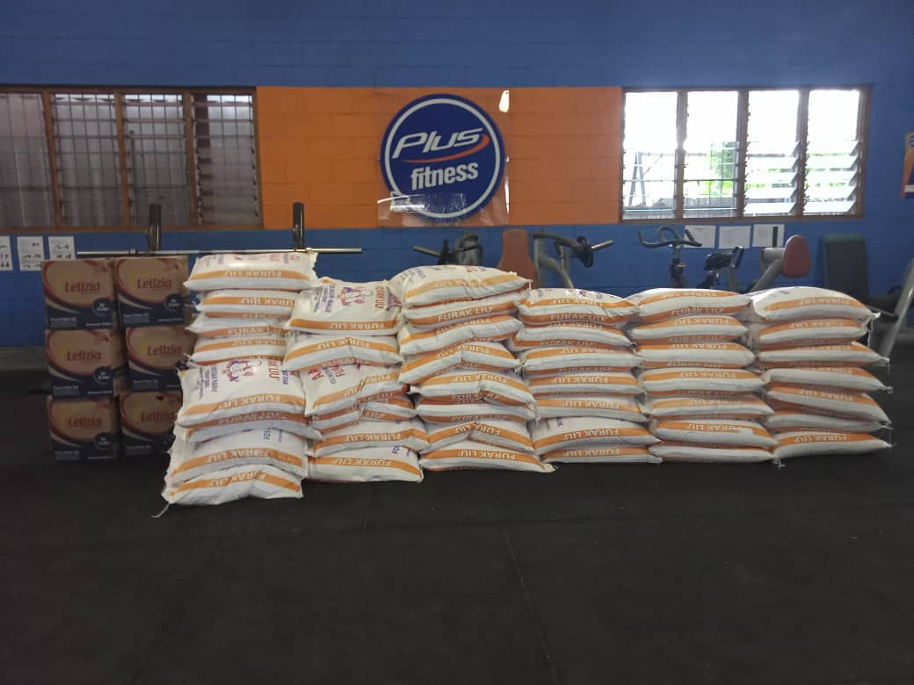

4 ROWS OF 20KG BAGS OF RICE (TOTAL 192)
As Manager Dede is a registered architect, he has organised 2 other architect friends, gym members and relatives to help him investigate areas in need of assistance. The outcome is many houses have been damaged and need maintenance or rebuilding.
The government has delivered some building items to some families, but they are left to rebuild on their own properties, many families did not receive assistance.
One of the families we have been able to help reside in one of the worst affected areas – Terra Santa, Tasi Tolu - Dili.
Many houses are cement so after the floods they were able to be cleaned out. The family we assisted consists of 2 parents, 3 children, Wife’s brother and his wife and 2 children (4 adults and 5 children). Their home was made of wood and iron and was mostly demolished.
Manager Dede and the team rebuilt the top floor and structures so the whole family can live upstairs until they can rebuild the lower floor.
TOTAL COST TO CENTRE - $1,848 USD
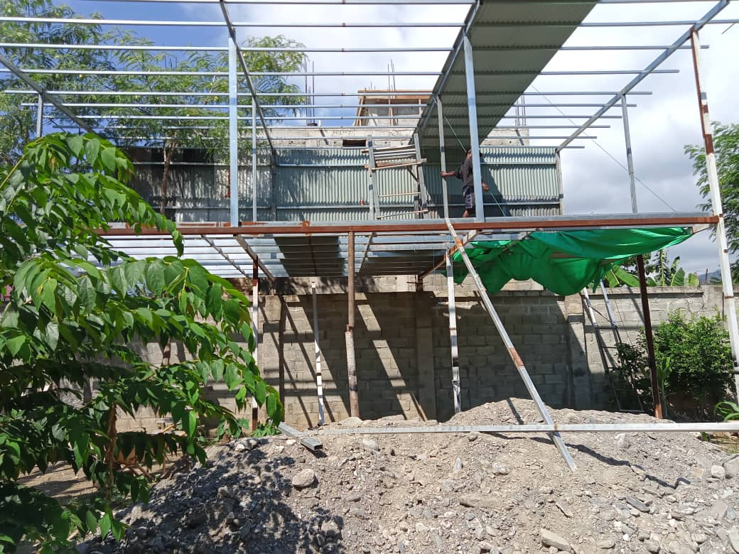
By having staff on the ground and many other contacts I have been able to ascertain with Manager Dede that although many people are receiving assistance there are still many people who are not.
University students that have come from the Districts into the capital of Dili to study mostly reside in guest houses. If they don’t have part time jobs, their families in the Districts send them money to survive.
Due to the COVID lockdown they are not classed as displaced people and they are often unable to receive help. Some of these students are not able to travel home to the Districts and their families can’t get to the bank to transfer money.
At this stage we have chosen 192 students from the hardest hit areas to support. Last week Managers Dede and Atisi organised University Student Supervisors to bring groups of the students to the Centre where they presented their National ID card to prove they were from a District, then they presented their University card to prove they were based in Dili to study.
Each student received –
- 20kg sack of rice - $12.55 USD (Total 192 sacks = $2,409.60 USD)
- 2 litre of cooking oil (Total 192 bottles = $803.20 USD)
- 200 kg of fresh green produce dispersed among 192 students – 80c per kg = $160 USD
- (purchased from our Australian friends from Farm Pro Ermera District)
- Carry bags for produce - $14 USD
- 2 facemasks sewn at the Centre (Total 192 = $384 USD)
TOTAL COST TO CENTRE - $3,770.80 USD
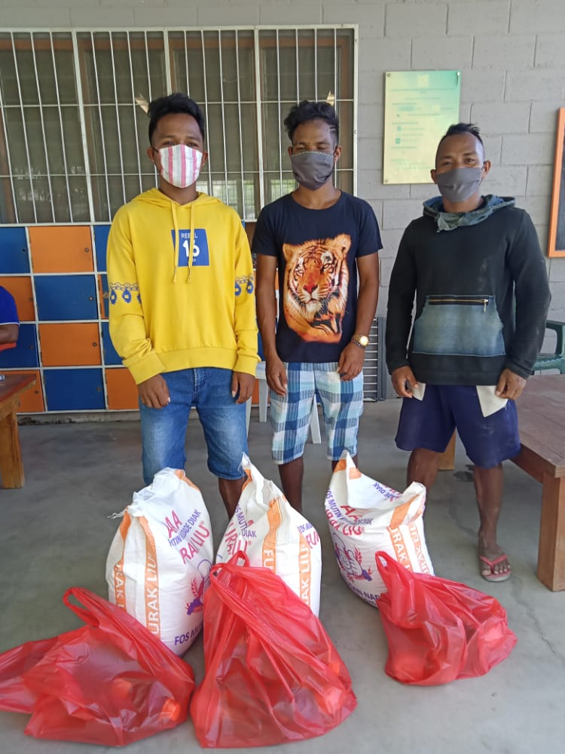
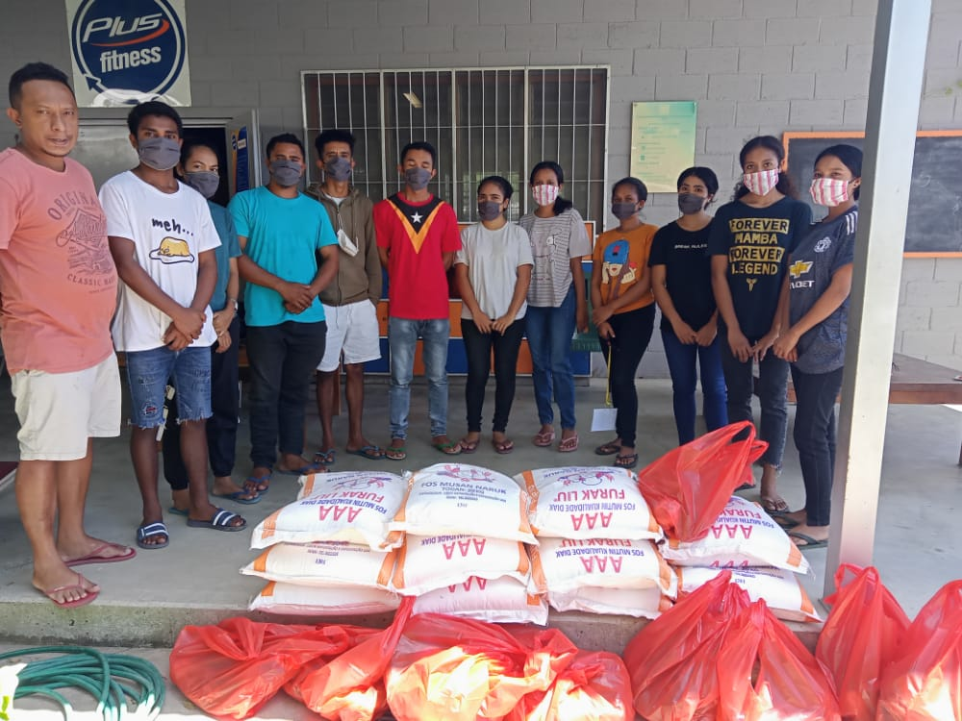
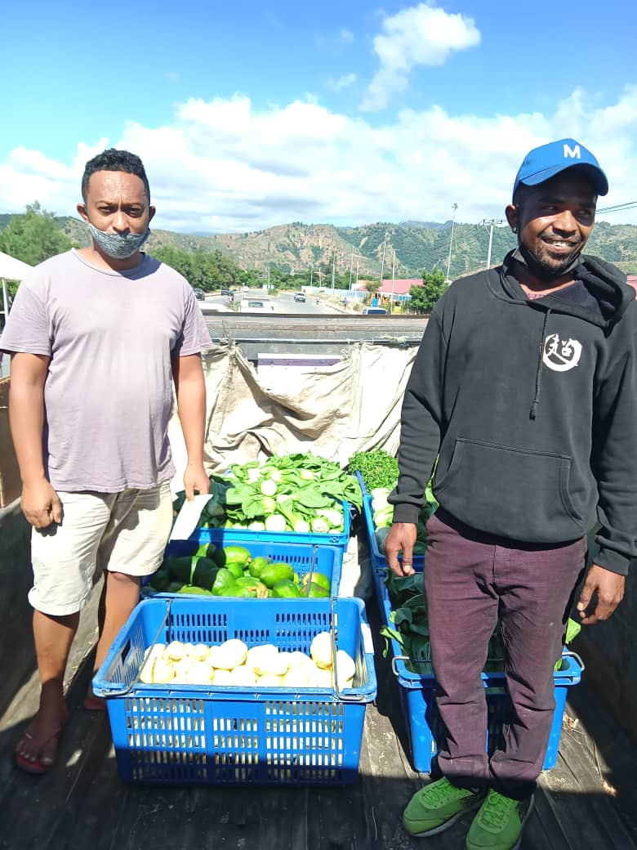
We will continue to investigate who needs our assistance for food and essentials as well as families that require materials to fix their homes.
The more money we raise the more families and individuals we are able to assist.
On the Australian front I would really like to push the sale of the black barista aprons that our sewing women have made. I have 1,000 of them stored in my garage and would like to sell them off for $10 each – some of the money would go to our Centre and some for assisting in rebuilding and fixing our members and neighbours’ homes affect by flood.
If you are able to help sell these aprons or would like to purchase some -please contact me via email.
On behalf of our Centre staff, members and the people of Timor-Leste that need us more than ever right now – thank you – for all the donations and support.
TOTAL COSTS FOR THE CENTRE - $7,278.80 USD (APPROX $9,700 AUD)

Kind regards,
Libby Bleakley
Rotary Club of Blackheath
District 9685 Australia
Founder/Director
Sentru Formasaun Ba Juventude no Comunidade
Centre of Learning for Youth & Community
Timor-Leste
RAWCS Project:33-2014-15
Email: ebleakley@live.com

